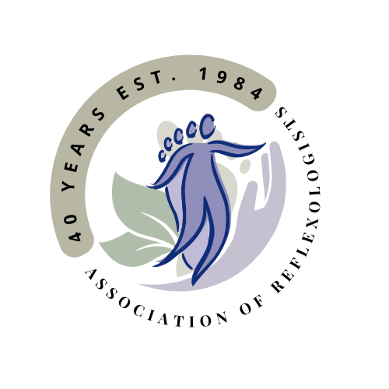

Personal Path Reflexology
Terms and Conditions
I am a full member of the Association of Reflexologists (AoR). Being a full member of the AoR demonstrates that I have completed a quality, nationally recognised Diploma in Reflexology and have support from the AoR.

As an AoR member:
- I am bound by the AoR Code of Practice and Ethics.
- I follow the AoR Good Practice Policy and hygiene guidance to ensure client safety.
- I will always be adequately insured for medical malpractice /professional indemnity requirements.
- I comply with the AoR Continuing Professional Development requirements which ensures my practice is kept up to date.
- I am compliant with GDPR data protection, please see the separate Privacy policy. Your information will remain confidential at all times.
- As a professional and highly qualified reflexologist with AOR status, I will provide you with the appropriate bespoke treatment and support.

1. Appointments

- When making an appointment you agree to the Terms and Conditions.
- When making the appointment you agree to a consultation with me, prior to the treatment and you will disclose any relevant medical or lifestyle information.

2. Fees
- The fees are as follows; the balance is payable at the time of treatment either cash or bank transfer.
- A deposit of £25 is required on booking
- Initial consultation £65 (approx. an hour and 15 minutes)
- Subsequent treatments £55 (approx. 50 minutes)
- A course of treatment (include initial consultation and 6 further treatments) usually weekly. £395 total price. This will be offered at £380 a £15 discount Payment is required prior to booking the course.
- I reserve the right to choose to use discretion regarding the application of any discounts.
- Payment can be made via - Cash, Bank Transfer, or Cheque.

Other information
- If you have a cough, a fever or loss of taste and smell or have been in touch with anyone with these symptoms please contact me as we may need to postpone your appointment.
- If you present with any condition or symptom which could be a contraindication, I reserve the right to postpone our treatment until medical advice is sought.
- Please do not book an appointment if you are due a blood test within 48 hours of your treatment

3. Cancellation Policy
- I have a 24 hour cancellation policy. As you are aware the business is dependent on the number of clients I can see in the clinic hours. Therefore, if you are unable to make a previously arranged appointment, I request that you provide me with at least 24 hours notice. This will allow me the option to re book the time slot with someone on the waiting list.
- Less than 24 hours notice may result in a fair-use fee of up to 100% of the usual treatment cost. This fee will be required to be settled prior to any future bookings.

4. Deposits
I request a deposit of £25 upon booking an appointment from all clients. Appointments made under this deposit scheme are able to be rescheduled with more than 24 hour notice. Changes or cancellations less than 24 hours notice the deposit will be withheld as stated in the cancellation policy above and subject to company discretion

5. Treatment packages
- I offer the option to book a package of treatments. These are provided at a reduced price as they are paid for in advance.
- These reduced price treatments must be booked and used within 6 months of initial consultation.
- Where an appointment is booked and missed, the cancellation policy will apply.
- These treatments are non-refundable.

6. Vouchers
- I supply the option to buy vouchers for treatments. These may be given as gifts.
- These treatments must be booked and used within one year of issue.

7. Use of background music
- I only play Royalty free music within the business and therefore I am not required to have The Music License.

8. The use of Face Coverings
- I am happy to treat without myself or clients wearing face coverings
- If you prefer to wear a mask or would like me to please let me know

10. Special Treatment License
- As a member of the AoR, working under their high standards, I am exempt from requiring a Special treatments license by West Berkshire Local Authority.
- I have confirmed with the local council that I do not require a special treatment license.

